Finding Thread for the next Job

As an assistant, your job is to support the operator by looking ahead and staging the thread for the next job. As the operator, let the assistant know before your last two runs that you’ll need help pulling through the thread and rethreading the needles!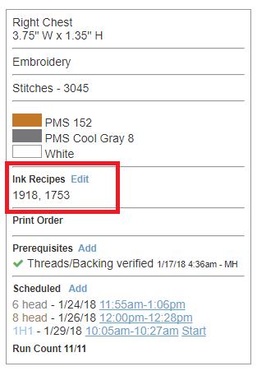

<~ Ink Recipe section of the production box will have the thread colors you should be using. In the case of this job, threads 1918 and 1753.

First look on the machine, the color you need might already be strung up. The thread color number is on the top of the cone. Then, check the thread wall. The number should be on the outside of the box.



The thread wall is loosely organized by number with lower numbers on the left

and higher numbers on the right.

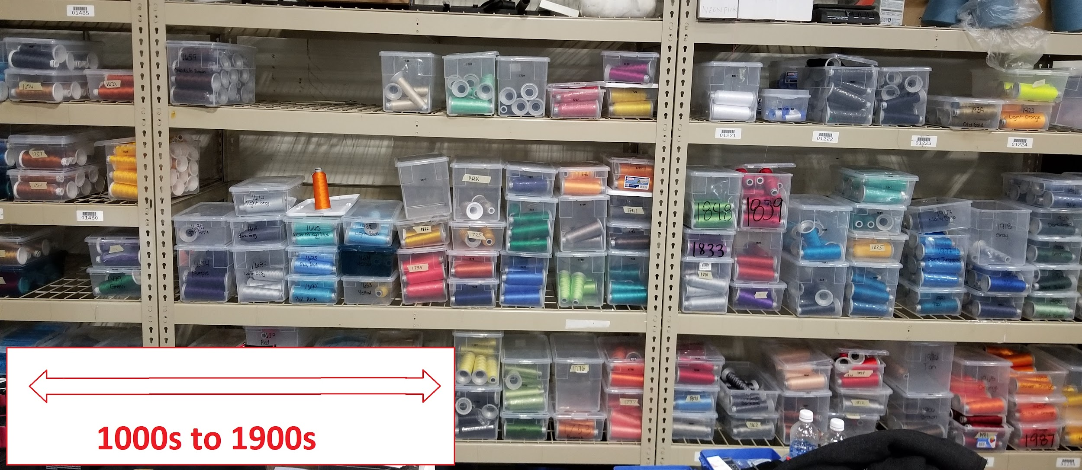

Boxes of thread are clustered by the hundreds. For Example, this is the 1600s thread.

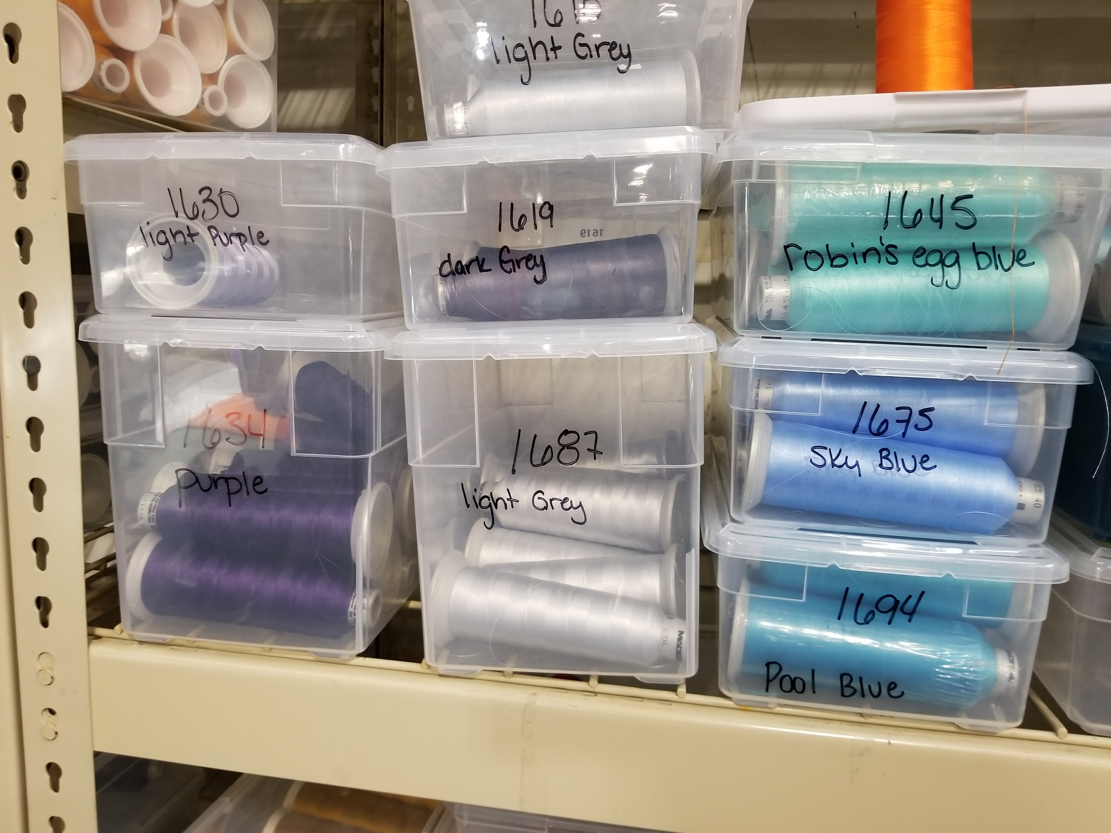

Before the operator finishes the current job, the threads need to be strung up for the next one.

\*Helpful reminder\* You have to replace thread not actively being used in the current design. So it they are using red, white and blue for the current embroidery job, use any of the other 12 needles to string up the next colors!

You can tie it in the back ahead of time and once the job is finished, pull the thread through and rethread the needles.

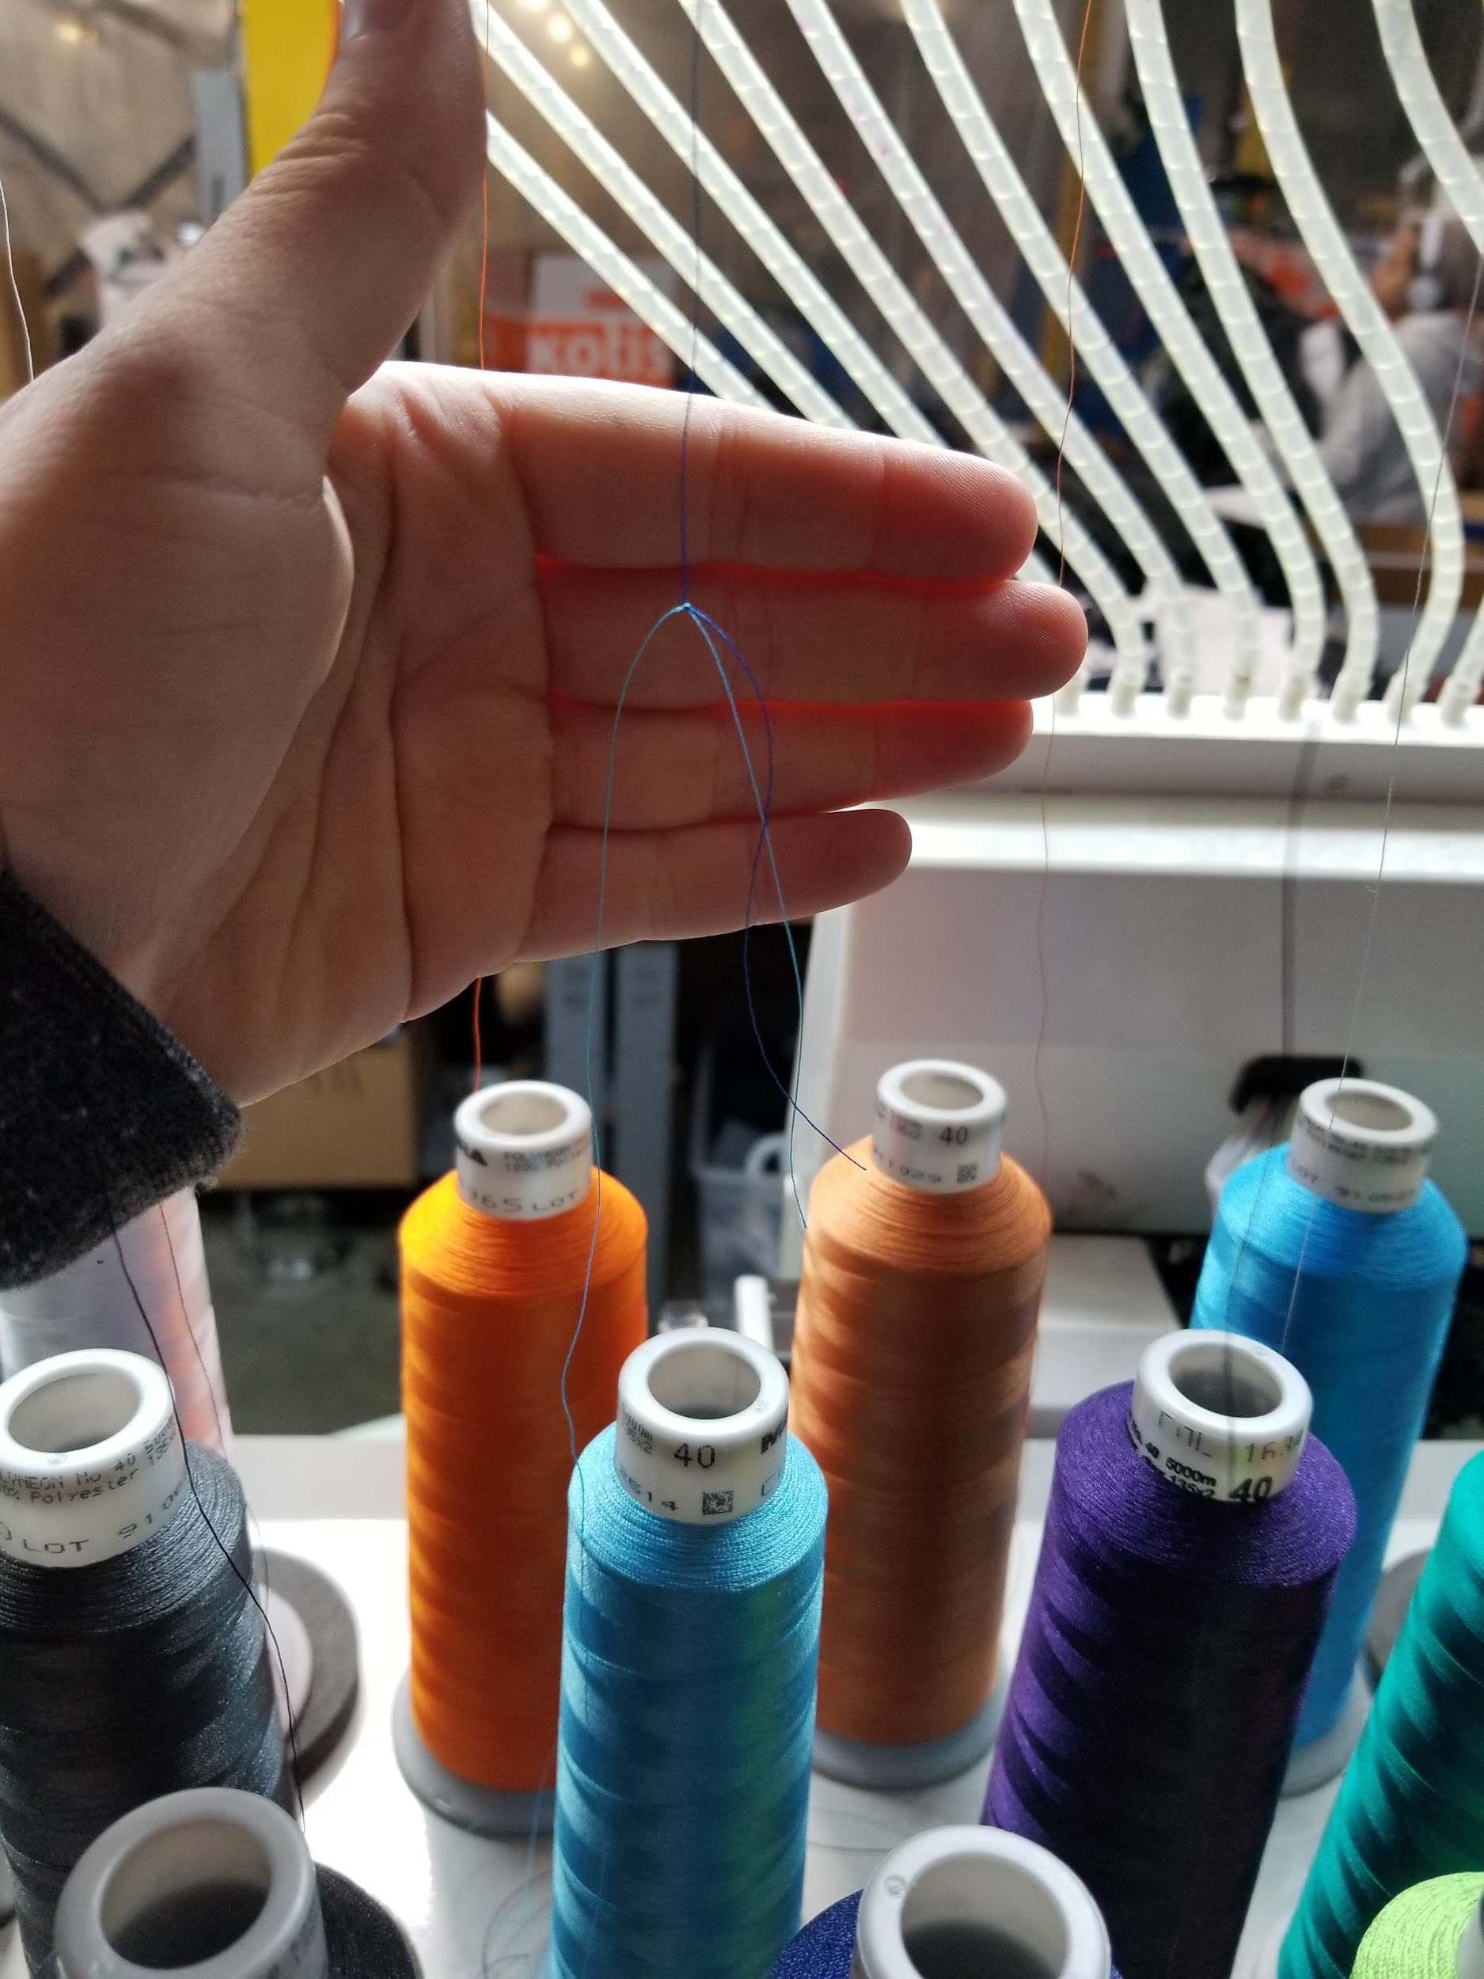

The operator should be assisting with this as well once they finish loading the next file onto the machine.

If the next job doesn’t have colors picked out yet, please follow the process in the PreReq Expectations Emb. document.



Once you have strung up the threads for the next job, take a moment to clean up the spools of thread taken off of the machine. Again, the thread number is found at the top of the spool. Match it with the number on the box. If there is less than 8 spools in a box, alert the manager to replenish stock.

If there is no box, place with other single spool variety samples.

Please use the following POs to complete the activity form:

Example 1: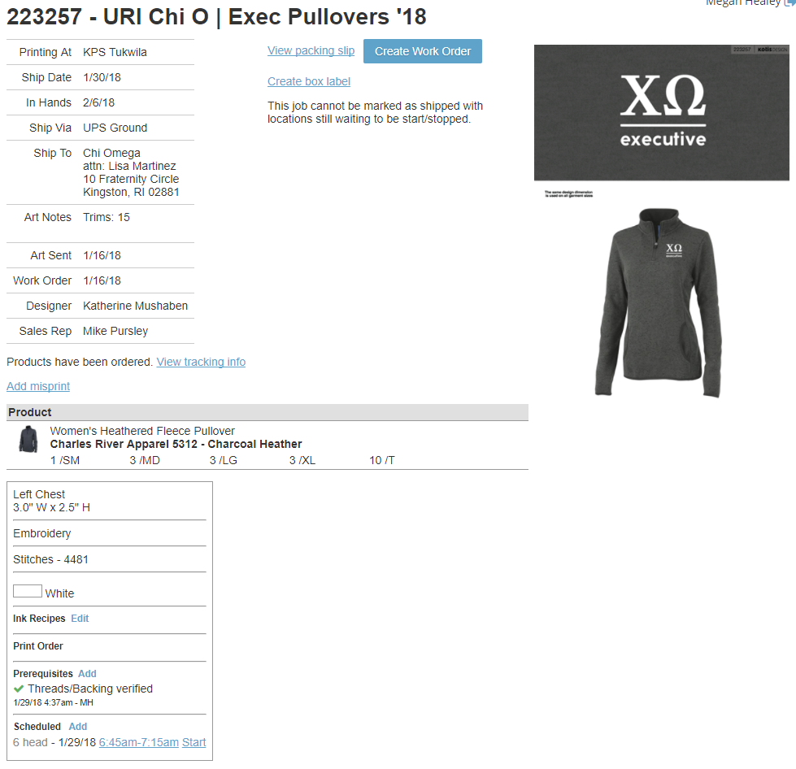

Example 2:

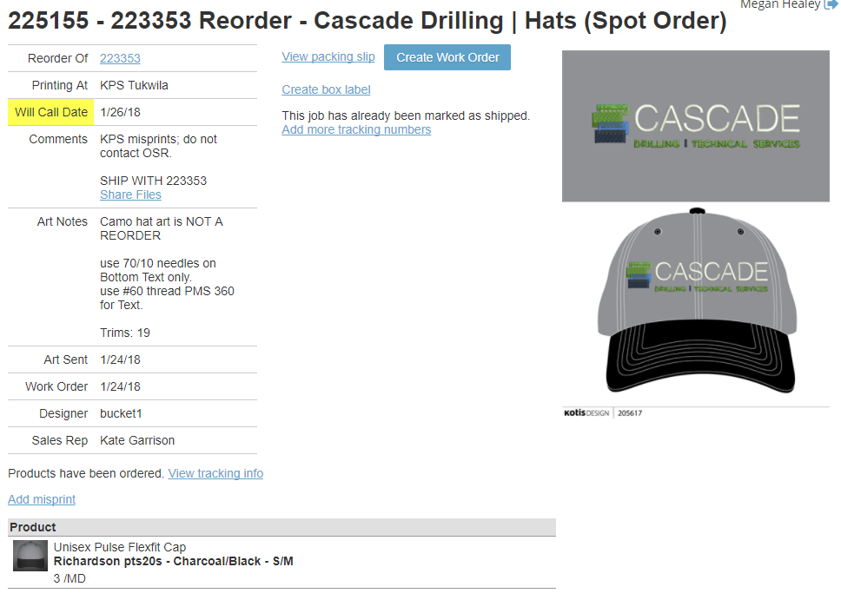

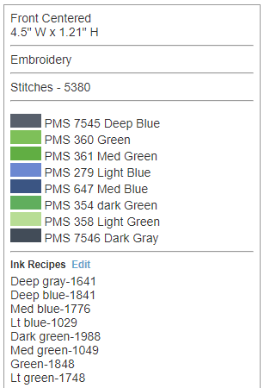

Example 3:

